

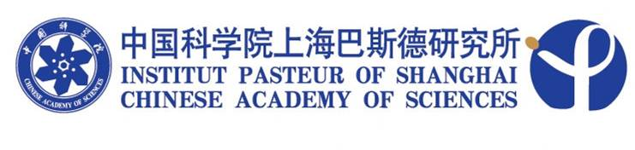

SEMINAR

Title: Innate control of vaccine immunogenicity by nucleic acid adjuvants

Speaker: Ken Ishii, M.D. / Ph.D.
Laboratory of Adjuvant Innovation, National Institute of Biomedical Innovation

Time: 14:00, November 10 2010 (Wednesday)

Venue: Conference room, 4th floor
Institut Pasteur of Shanghai

Host: Prof. Zhong Huang

