

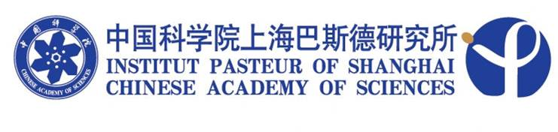

SEMINAR

Title: Perioperative Therapy In Patients With HIV Infection

Speaker: Baochi Liu，Ph.D.
Shanghai Public Health Clinical Center, Fudan University

Time: 14:00, November 09 2010 (Tuesday)

Venue: Conference room, 1th floor
84 Sinan Road

Host: Prof. Jianhua Wang

