

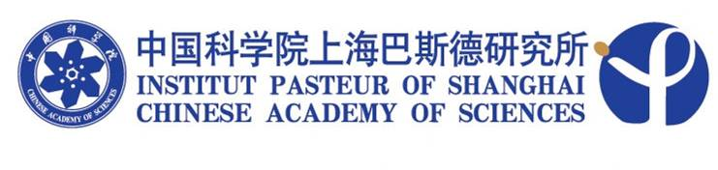

SEMINAR

Title: Recent Advances in HIV-1 accessory protein Biology

Speaker: Eric Cohen, Ph.D.
Director, Immunity & Viral Infections Research Axis, IRCM, Montréal

Time: 14:00, October 19, 2010 (Tuesday)

Venue: Conference room, 4th floor
Institut Pasteur of Shanghai

Host: Prof. Bing Sun

