

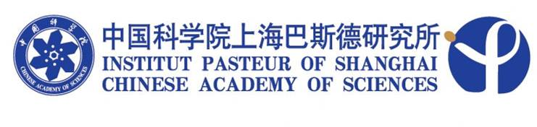

SEMINAR

Title: Curing HCV infection by treating its receptor addition: Fact or Fiction?

Speaker: Tianyi Wang, PhD, Assistant Professor
Department of Infectious Diseases and Microbiology (IDM), University of Pittsburgh

Time: 10:30, October 18, 2010 (Monday)

Venue: Conference room, 4th floor
Institut Pasteur of Shanghai

Host: Prof. Jin Zhong

