

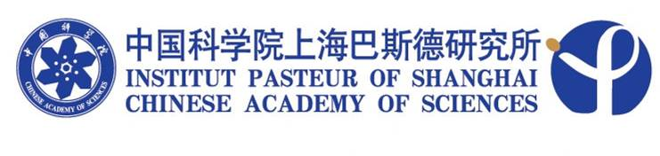

SEMINAR

Title: Mass spectrometry analysis of lipid oxidation, a diagnostic tool for inflammatory diseases

Speaker: Zhiping Wu, Ph.D.
Senior Scientist, Cleveland Clinic Foundation

Time: 10:00, October 11, 2010 (Monday)

Venue: Room 402, Conference room
Institut Pasteur of Shanghai

Host: Prof. Hui Xiao

